FIRST 5 SAN BENITO
CHILDREN AND FAMILIES COMMISSION

*SPECIAL* COMMISSION MEETING

Meeting Minutes
March 2nd, 2023
1. CALL TO ORDER

Chair Dr. David Redman called the meeting to order at 12:17 am

ROLL CALL / INTRODUCTIONS

Commissioners Present:
- Dr. David Redman
- Dr. Marni Friedman

- Elias Barocio
- Tracey Belton

Commissioners Absent:
- Supervisor Bea Gonzalez
- Mary Damm
- Margie Barrios

First 5 Staff Present:

- Lisa Faulkner
- Carly Offermann
- Alexia Magana
- Sarah Beatie

Family Impact Center Staff Present:
- Monica Hernandez

Guests:

2. AGENDA MODIFICATIONS

NONE

3. PUBLIC COMMENT

NONE

4. DIRECTOR’S REPORT

Lisa Faulkner shares information regarding changes in staffing to come.

5. Fund Balance transfer to begin construction on the Family Impact Center Commercial Kitchen and Pantry Project in the amount of $200,000.00

Dr. Marni Friedman made a MOTION to approve delegating authority to the Executive Director to encumber $200,000.00 from the First 5 San Benito Fund Balance account, and transfer if necessary, to the Operating account to begin construction on the Family Impact Center Commercial Kitchen and Pantry Project.

SECOND: Elias Barocio All in favor, MOTION PASSED.

6. First 5 California Home Visiting Coordination and Regional Technical Assistance Initiative.
Elias Barocio made a motion to approve item 6.1, item 6.2, and item 6.3
Item 6.1 Approve First 5 San Benito to participate in Region 4 application for the First 5 California Home Visiting Coordination and Regional Technical Assistance Initiative.
(Attachments B, D, E, F)

Item 6.2 Approve First 5 San Benito to lead Region 4 in the First 5 California Home Visiting Coordination and Regional Technical Assistance Initiative.

Item 6.3 Authorize Executive Director, at her discretion, to submit grant applications for funding that meet the strategic plan set forth by the Commission

.
SECOND: Dr. Marni Friedman All in favor, MOTION PASSED.

7. San Benito County INVOICES for FY 2022-2023 OPEB and CalPERS Pension Liabilities for a total amount of $14,354.37.
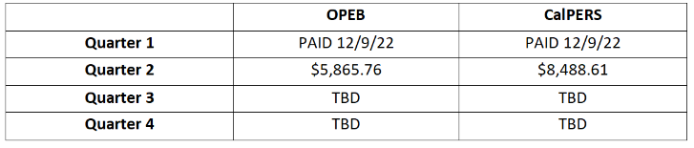

Dr. Marni Friedman made a MOTION to authorize the Executive Director to pay San Benito County INVOICES 2023-00000003 and 2023-00000004 for a total amount of $14,354.37.
.
SECOND: Elias Barocio All in favor, MOTION PASSED.

8. ANNOUNCEMENTS

Upcoming meeting focused on strategic plan moving forward. Looking at sustainability. Community Center project discussion. Past plan focused on infrastructure.

Commission elections will be held at the next meeting.

9. OTHER - FUTURE AGENDA ITEMS

Next Commission Meeting: Wednesday, April 5, 2023 @ 12noon – 2pm
Next Executive Committee Meeting: Wednesday, April 5, 2023 @ 11:30am – 12noon
Next Financial Committee Meeting: Thursday, March 23, 2023 @ 10am – 11am

No further business coming before the Commission, meeting adjourned at 12:27 pm.

